INSTITUTO SUPERIOR TÉCNICO

ADI – Aprendizagem e Decisão Inteligente

MEIC 2016-2017 – 2ºt Semestre

Grupo 27 – Alameda

Pedro Duarte – 78328

Pedro Guerreiro - 78264

**Homework 2 – Markov Decision Problems**

**Exercise 1**

X = {

(1,1), (1,2), (1,3), (1,4),

(2,1), (2,2), (2,3), (2,4),

(3,1), (3,2), (3,3), (3,4),

(4,1), (4,2), (4,3), (4,4)}

A = { up, down, left, right, stay }

NOTA: (1,2) significa “lobo na posição 1, lebre na posição 2”, etc.

Pup = Pdown =

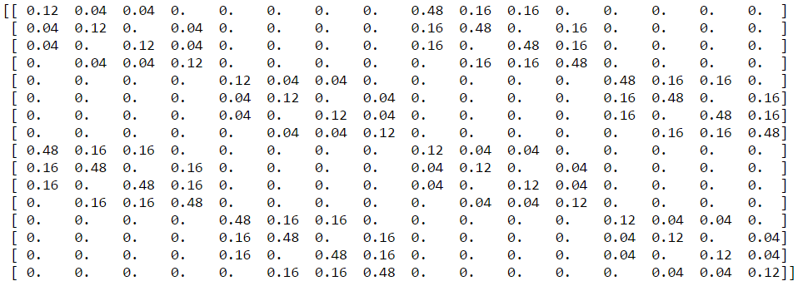

Pleft = Pright =

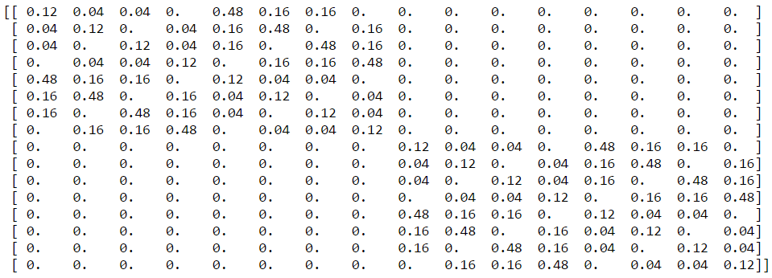

Pstay =

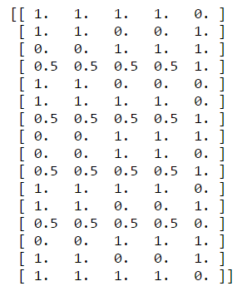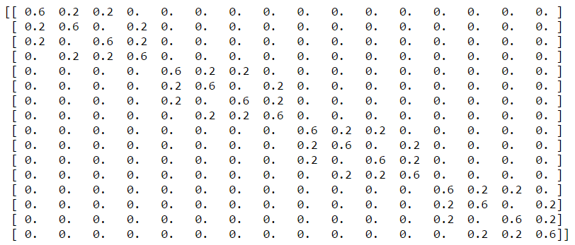

C =

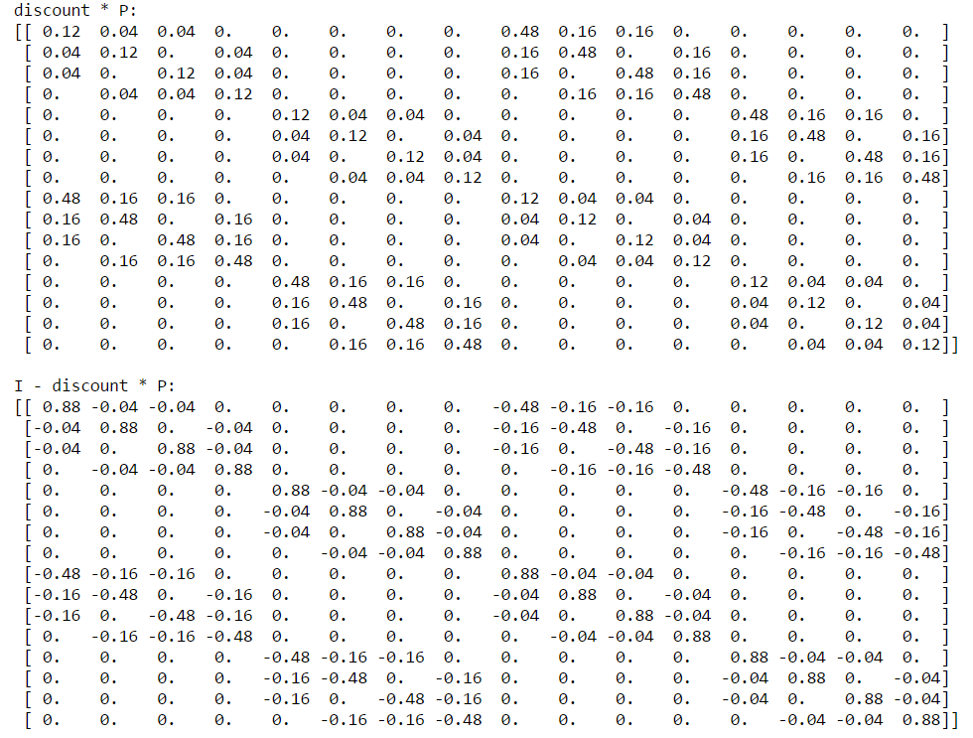

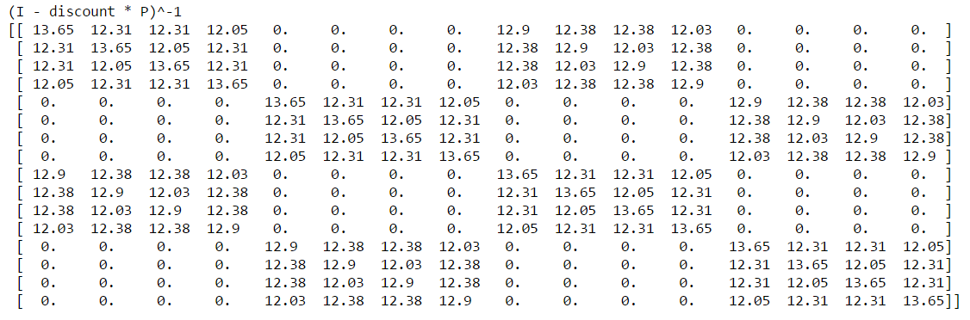

J =https://i.gyazo.com/277e000bc06ff626af4b9ed50334459d.png